Financial Literacy
Senior Resource Center, Inc.
In our Sixteenth Year

Newsletter –May 2024
Phone: (757) 385-2175 | Website: https://www.vbsrc.com | Email: info@vbsrc.com
Facebook: https://www.facebook.com/vbsrcevents/

Lecture and Pot Luck Lunch
Wednesday, May 15 11:00 am

Moyra Fleming, from Atlantic Union Bank (the branch at Sandbridge/Princes Anne Rd. intersection) will educate us regarding financial fraud and protecting our bank accounts. We’ve all heard about the many scams that have bilked seniors out of thousands of dollars, so come and learn how to avoid being a victim. The month of April was National Financial Literacy Month, which highlighted the benefits of being savvy about our personal finances and learning to manage our own personal and household finances better. Here is your chance to gain that needed education.
As always, bring a lunch dish to share and a non-perishable food item for the area Food Pantry. Keep in mind that there is no cost to attend the SRC, so we encourage you to spend a dollar or two on a food item to help keep Chairty Methodist’s food pantry’s shelves stocked.

Mothers’ Day Tea
Friday, May 10 1:00 pm

Join us for this annual event, honoring mothers and grandmothers. Husbands and dads are welcome, too. Dress up if you’d like, wear a fancy hat or not, bring a dessert to share, and enjoy an array of teas and desserts. You may bring your favorite tea cup and saucer, if you’d like to be proper.
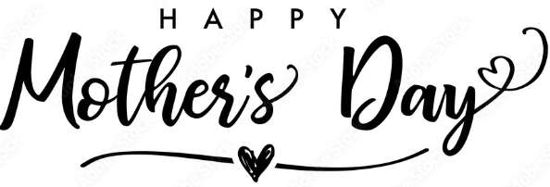

Getting Started with Hoopla
Friday, May 10 2:00 pm
Pungo-Blackwater Library

Feeling unsure about how to access the library e-books and audiobooks? Bring your devices, fully charged, to this hands-on workshop where we will help you install the apps and successfully navigate them to build your personal digital library. Class is for adults 18+ and registration is required. Cal 757-385-0150 to sign up.

Senior Showcase
Wednesday, May 29 9:00 am - noon
Princess Anne Rec Center

This is an annual expo provided by the Virginia Beach Mayor’s Commission on Aging. You can obtain a lot of helpful resource information from vendors, enjoy a free box lunch, and enjoy entertainment by “Frank Sings Frank.” Vendors will provide lovely door prizes, and you might just be a winner. You need to R.S.V.P. in order to receive lunch, so call 757-385-2689 or go to: www.vbmcoa@vbgov.com . The SRC will have a display table in the entrance hall, so stop by and say hello to our volunteers.

Stamp Prices May Cost More Again Soon

The United Sates Postal Service announced a proposed price increase. If approved, the rate would increase 7.8%, from $.68 to $.73. That’s a bigger increase than usual, and keep in mind there was an increase of $.02 just this past January. So, be sure to stock up on Forever stamps now and avoid having to pay more come July 14.
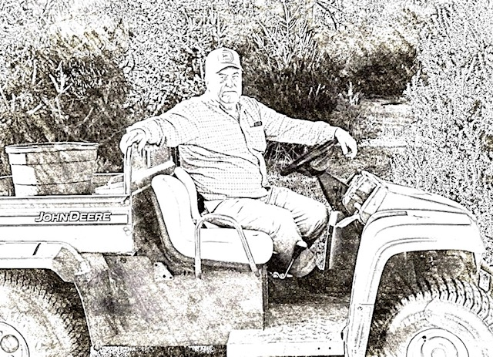
In Memory and Honor of
Jim Bright

We lost a true gentleman and a wonderful neighbor and friend when dear Jim passed away on March 22, 2024, after a brief and difficult illness. Jim, along with his wife Anne, was always the first to jump in to help others, doing good deeds every day, never wanting to take credit for all that he did without being asked. We will miss him dearly. Rest in peace, Jim.

The following poem is dedicated to Jim and fits him to a T:
The Dash
by Linda Ellis Written in 1996 but even more meaningful in these troubled times.
I heard a man who stood to speak at the funeral of a friend.
He referred to the dates on his tombstone, from the beginning to the end.
He noted that first came the date of his birth, and spoke of the following date with tears.
But he said what mattered most of all was the dash between those years.
For that dash represents all the time that he spent alive on earth.
And now only those who loved him know what that little line is worth.
For it matters not how much we own-- the cars, the house, the cash.
What matters most is how we live and love and how we spend our dash.
So, think about this long and hard…are there things you’d like to change?
For you never know how much time is left, you could be at dash mid-range.
If we could just slow down enough to consider what’s true and real,
and always try to understand the way other people feel.
And be less quick to anger, and show appreciation more.
and love the people in our lives like we’ve never loved before.
If we treat each other with respect, and more often wear a smile,
Remembering that this special dash might only last awhile.
So, when your eulogy’s being read with your life’s actions to rehash,
Would you be proud of the things they say about how you spent your dash?

Dear Jim spent his “dash” in an exemplary way- caring about others and doing good deeds every day. Let’s all follow Jim’s beautiful example and help our world be a better, more loving place.

My Grandma’s Hands
by Gladys Cole in honor of Mother’s Day

My grandma’s hands could heal my hurt or cool my fevered brow.
Her care- and not a learned degree-experience taught her how.
I always knew that I was loved by deeds, a hug, or smile.
She proved it in so many ways, ’twas special-grandma style.
Sometimes she was my playmate, oft times my mentor, too.
I learned to take life as it came; that’s helped me my life through.
Then I grew up and she grew old, yet our love had no end.
For I was blessed as long as she lived, because grandma was my friend.

Memorial Day
May 27

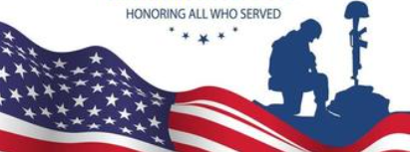
Formerly known as Decoration Day, Memorial Day commemorates all the men and women who have died in military service for the United States. It was originally begun to honor Union soldiers who died during the Civil War, but after World War I, it was extended to include all U.S. military who died in any war or military action. The current name for this observance, Memorial Day, came into use after WWII. Take time on this holiday to be thankful for all those who sacrificed their lives so that we could remain free. Memorial Day is often confused with Veterans’ Day in November. Remember that Memorial Day honors those who died while serving in the United States military.
Summit 55+
March 29

This first-time event was provided by Virginia Beach City Councilman Chris Taylor. The purpose of the event was to introduce city programs that benefit seniors. Barbara Henley was invited to participate and present regarding the Senior Resource Center. There was a large audience in attendance, and they were very interested in what we have accomplished. We can be proud that we are the only senior program like it in the entire city, and Mr. Taylor hopes our program can be replicated in other areas of Virginia Beach. While sharing our story with the audience, we were reminded that we have been in existence for 16 ½ years- quite a feat!

Farmers Market Friday Night Hoedowns

These free concerts are held every Friday night, from April through October at the Farmers Market. That’s located at 3640 Dam Neck Road, at the intersection of Princess Anne and Dam Neck Roads, across from Landstown Shopping Center. The concerts are held rain or shine, from 7-9 p.m., and line dancers are welcome to join in. It’s suggested that you bring your own blanket or chair.

May 2024 Schedule of Bands
May 3 Dallas Band
May 10 Timeline
May 17 The Country Rockers
May 24 Timeline
May 31 Raw BeeTs

Was Your Wallet Stolen?

Identity theft is prevalent, but you may be the unfortunate victim of the actual theft of your wallet, or perhaps you accidentally left it behind at the store. Here’s some tips from AARP about what you need to do:
- Call your financial institutions and inform them that your accounts may be compromised. Usually, those accounts then will be closed and a new account opened.
- Call the Division of Motor Vehicles, if you have a driver’s license.
- Alert your health insurers- primary and secondary.
- File a police report to document the case.
- Put a fraud alert on your credit report to stop anyone from getting a new credit card in your name.
You can find help with all of these steps at: www.identitytheft.gov.

Reducing Financial Clutter at Home

summarized from an article by Jill Schlesinger in the April 7, 2024 Virginian Pilot. Since you may have just completed filing your income tax return for 2023, it’s a good time to sort through your financial files and see what you can discard. Many of us hold on to paper statements for many years, reluctant to trash them. Many of you may not receive most of your financial statement and reports by mail anymore, opting to get them via email, so you have far fewer files to purge at home. If you do need to get rid of paperwork, bring them to the SRC and use our shredder.
- Tax returns-The IRS can include returns filed within the last 3 years in an audit. If they find a substantial error, they may add additional years, but usually the IRS does not go back more than 6 years. So, keep your returns and supporting documents for six years, just to be safe.
- Bank and investment statements- You usually can access all of these statements online, but it may be helpful to make note of any purchases and sales confirmations for tax purposes. To make it easier for you at tax time, create a file online or in a paper file called “Tax Prep”, so you easily refer to the information at next year’s tax time.
- Credit card /utility/phone bills-Unless you need to reference something for tax or business purposes, or for proof of purchase for a specific item, you can shred these statements after 45 days. Flag what you might need for taxes, including charitable contributions.
- Real estate closing/mortgage/home improvement documents-It is recommended you retain these papers for as long as you own the property, including property deed, home inspection/ home warranty/survey’, mortgage documents and home improvement/major purchases receipts for insurance claims or tax purposes when you sell your home.
- Keep forever birth and death certificates, Social Security cards, marriage licenses and divorce decrees, military discharge papers, and estate documents. While you’re at it, check your credit record/score. You can get a free credit report once a year, from 3 major companies: Equifax, Experian and TransUnion. Federal law gives you the right to receive one free copy every 12 months from each of these agencies. Go online at annualcreditreport.com or call 1-877-322-8228.
By the way, have you ever heard of a FICO score? FICO stands for Fair Isaac Corporation. FICO was a pioneer in developing a method for calculating credit scores and most lenders uses this system when deciding whether to offer you a loan or a credit card. Many banks offer the FICO score, so check with your financial institution. A FICO score is really just a 3-digit snapshot of your credit history.

Parking Permits for Seniors

The City of Virginia Beach provides special permits for those residents 65 or older which allows you to park for free in the 4th Street(next to Rudee Inlet), Sandbridge and Little Island (Sandbridge) municipal parking lots. You must apply online through the City’s Permit Portal. Once approved, you can start parking immediately. The old process of having a decal on your front bumper is no longer in effect. No physical permit is issued. Go to virginiabeach.gov/. to apply. You’ll need to have your driver’s license and vehicle registration handy. For information call 757-385-2900.

Virginia Beach District 2 City Council Meetings

Are you aware that Barbara Henley, the City Councilwoman for District 2, holds a monthly community meeting to update residents on current city projects and issues? Residents will have an opportunity to build relationships with other members of the district, engage and participate in the conversation. And have their questions addressed. These meetings are held on the 4th Thursday of each month, in Building 19, (Human Resources) at the Municipal Center. The building is at 2424 Courthouse Drive, and the meeting is held in Training Rooms A and B. Take advantage of this great resource to keep up on city happenings.

TRIAD

Another helpful resource, TRIAD is a joint effort of the Virginia Beach Sheriff, an AARP representative as well as senior and retired volunteers who work together to reduce criminal victimization of seniors. It is supported by S.A,L.T., (Seniors and Law Enforcement Together) and aims to create a sense of security and decrease fear among local seniors, through education. Meetings are held monthly, the 3rd Saturday, at 10a.m at Marion Manor, 5345 Marion Way, VB, VA 23462. All seniors are welcome. You do not need to preregister, and there is no cost. Call Gary Zalas at 757-385-6757 for more information.

